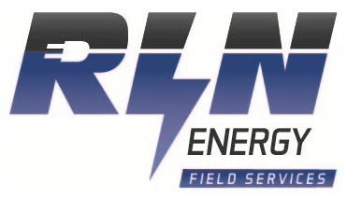
150KW Cold Weather Ready for Operation on well head gas
Item Number: 20941
Manufacturer: SRC
Fuel Type: Natural Gas
Model: 466TA
KW: 150
Hz: 60
Voltage: 480
RPM: 1800
Price: $68,800.00 USD Per Unit plus Freight
More Information: (Several) SRC 466TA Industrial Generator Sets packaged by RDO. Rated at 175 kw, 60hz, 240/480 v, 1800 rpm, 3 phase, single bearing, . Complete with Cummins Stamford Alternator, NEMA MG1 Insulation, Electronic Governor, Dry exhaust manifold.

Approx Dimensions: L 182in x W 48.4in x H 84.1 in
Approx. Weight: 6500 lbs

Please call for more details.